Delta Team- Milestone #3

Paul Fralix, Sylvester Brandon, Reed Bunnell, Tyler Freese

CSD310 Bacchus Winery Case Study

07/20/2025

Employee time. During the last four quarters, how many hours did each employee work?

**Report #1**

This report calculates the total hours worked for each employee over the last four (4) quarters.

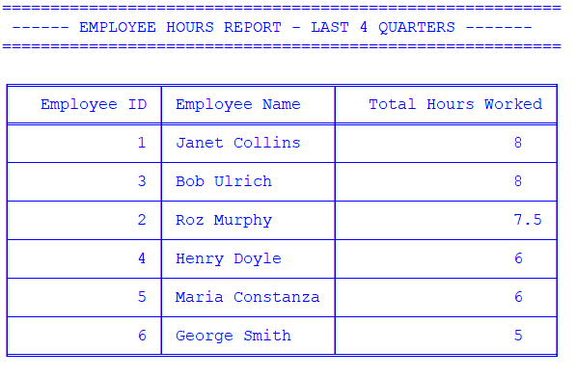

Question: Regarding wine distribution, are all wines selling as they thought? Is one wine not selling?

**Report # 2**

This report calculates the sales of each wine and advises if a wine does not have any sales.

Question: Are all suppliers delivering on time? Is there a large gap between expected delivery and actual delivery? A month-by-month report should show problem areas.

**Report # 3**

This report shows the status of supply orders and if they were received after the expected arrival date.

Question: Which distributor carries which wine?

**Report # 4:**

This report shows which wine each customer purchased and the quantity purchased.

